**Week 2**

**Hamza Mushtaq**

**F20-1119**

Question no 1:

<!DOCTYPE html>

<html lang="en">

<head>

    <meta charset="UTF-8">

    <meta name="viewport" content="width=device-width, initial-scale=1.0">

    <title>Task 2</title>

    <style>

       div{ background-color: black ; color: azure; font-family: Arial;}

        body{background-color: black;}

        button{background-color: rgb(0, 255, 60); text-align: center; padding: 15px 20px; font-size: 16px; font-family: Arial; border :none}

    </style>

</head>

<body>

    <div >

        <h1>

            Start CSS Exercises

        </h1>

        <p>Good Luck </p>

        <button class="button" >

            Start CSS Exercise >

        </button>

    </div>

</body>

</html>

**Output:**

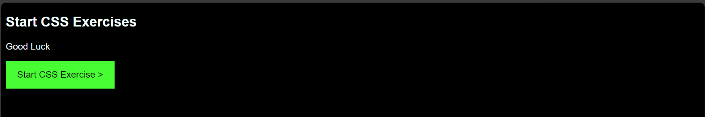

Question no 2:

<!DOCTYPE html>

<html lang="en">

<head>

    <title>Task 2</title>

    <style>

        body{background-color:rgb(18, 159, 234);}

        input{width: 50%; margin-top: 20px; }

        button{ background-color: red; width: 52%; margin-top: 10px;}

    </style>

</head>

<body>

    <form action="" style="margin-left: 25%; margin-right: 25%;">

        <input type="text" placeholder="Name*" required> <br>

        <input type="text" placeholder="Username*" required><br>

        <input type="password" placeholder="Password*" required><br>

        <input type="text" placeholder="Number*" required><br>

        <input type="text" placeholder="Email Id*" required><br>

        <button type="submit" >Register</button>

    </form>

</body>

</html>

Output:

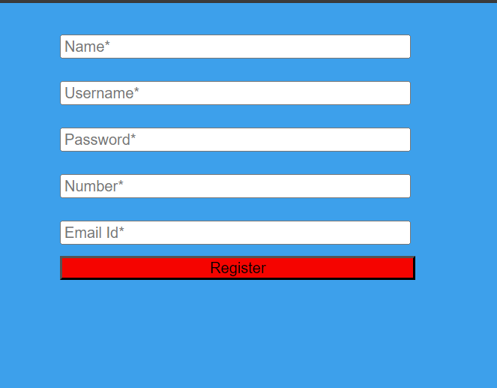

Question no 3:

<!DOCTYPE html>

<html>

    <head>

        <style>

        div.polaroid {

        width: 250px;

        box-shadow: 0 4px 8px 0 rgba(0, 0, 0, 0.2), 0 6px 20px 0 rgba(0, 0, 0, 0.19);

        text-align: center;

        margin: auto;

        }

        div.container {

        padding: 10px;

        }

     </style>

    </head>

    <body>

    <div class="polaroid">

    <img src="1.jpg" alt="" style="width:100%">

    <div class="container">

        <p>Lorem</p>

    </div>

    </div>

    </body>

</html>

Output :

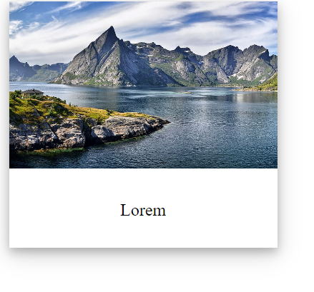

Question no 4:

<!DOCTYPE html>

<html>

  <head>

    <style>

      div.polaroid {

        width: 250px;

        box-shadow: 0 4px 8px 0 rgba(0, 0, 0, 0.2), 0 6px 20px 0 rgba(0, 0, 0, 0.19);

        text-align: center;

        margin: auto;

        animation: myfirst 5s 2;

        position: relative;

        animation-direction: alternate;

      }

      div.container {

        padding: 10px;

      }

      @keyframes myfirst {

        0% {

          left: 0px;

          top: 0px;

        }

        25% {

          left: 200px;

          top: 0px;

        }

      }

    </style>

  </head>

  <body>

    <div class="polaroid">

      <img src="1.jpg" alt="Norway" style="width: 100%" />

      <div class="container">

        <p>Lorem</p>

      </div>

    </div>

  </body>

</html>